**SPAIN ENDOSCOPY DEVICES MARKET**

According to Intelli, the Spain endoscopy devices market was valued at USD 890 million in 2024 and is projected to reach USD 1554.41 million by 2032, growing at a CAGR of 5.12% from 2024 to 2032.

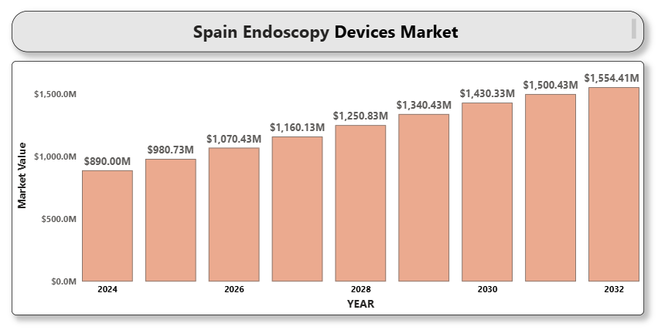

The endoscopy devices market in Spain is experiencing significant growth, driven by the increasing prevalence of gastrointestinal disorders, cancers, and chronic diseases that require minimally invasive diagnostic and therapeutic procedures. Technological advancements in endoscopic imaging, a rising preference for minimally invasive surgeries, and efforts to modernize healthcare infrastructure are key drivers of growth. Additionally, the aging population and the rise in outpatient endoscopic procedures are contributing to the growing demand for advanced endoscopy solutions in Spain.

**Spain Endoscopy Devices Market Definition**

Endoscopy devices are medical instruments used for visualizing, diagnosing, and treating conditions within the body's internal organs and cavities using minimally invasive techniques. These devices typically consist of a flexible or rigid tube, known as an **endoscope**, that contains a camera and light source to provide real-time imaging of the area being examined. The **Spain endoscopy devices market** includes various types of endoscopes, such as flexible and rigid endoscopes, as well as visualization systems, operative devices, and accessories.

Endoscopy procedures are used across various medical specialties, including **gastroenterology**, **pulmonology**, **urology**, **gynecology**, **orthopedics**, and **cardiology**, for both diagnostic and therapeutic purposes. The key advantage of endoscopy is that it allows healthcare providers to perform surgeries and diagnostic tests with minimal incisions, leading to reduced recovery time, lower risk of infection, and less pain compared to traditional open surgeries.

Technological advancements in endoscopy, such as high-definition imaging, 3D visualization, robotic-assisted procedures, and the development of capsule endoscopy (swallowable camera devices for gastrointestinal diagnostics), are expanding the applications of endoscopic procedures in Spain. The demand for endoscopy devices is further driven by the growing preference for minimally invasive procedures, aging population, and advancements in healthcare infrastructure.

**Spain Endoscopy Devices Market Overview**

The Spain endoscopy devices market is experiencing robust growth, driven by several key factors including the rising prevalence of chronic diseases such as gastrointestinal disorders, cancers, and respiratory conditions, which require endoscopic diagnostics and treatments. Spain's aging population, which is more vulnerable to these health issues, further accelerates the demand for endoscopic procedures. Additionally, there is a growing preference for minimally invasive surgeries due to their associated benefits, such as reduced recovery times, shorter hospital stays, and lower complication risks. Technological advancements in endoscopic imaging, such as high-definition visualization systems, 3D imaging, and robotic-assisted surgery, are expanding the capabilities of these devices and improving patient outcomes. The Spanish healthcare system is also increasingly adopting digital health technologies, which is fostering the use of advanced endoscopic equipment. Moreover, government initiatives aimed at modernizing healthcare infrastructure and improving diagnostic capabilities are boosting market growth. While challenges like the high cost of advanced devices and the shortage of skilled professionals persist, the market remains promising due to the ongoing investments in healthcare modernization and the growing demand for outpatient care.

**Spain Endoscopy Devices Market Segmentation Analysis**

*Market Segmentation by Product Type*

* **Endoscopes**
* **Visualization Systems**
* **Operative Devices**
* **Other Accessories**

Endoscopes accounted for the largest share of the market in 2024 due to their wide usage across various medical specialties. Technological innovations, such as robotic-assisted endoscopy and capsule endoscopy, are expanding this segment.

*Market Segmentation by End-User*

* **Hospitals**
* **Ambulatory Surgical Centers (ASCs)**
* **Specialty Clinics**

Hospitals dominated the market in 2024 due to the availability of advanced diagnostic equipment and comprehensive patient care services. Ambulatory surgical centers are also growing rapidly, benefiting from shorter procedure times and cost-effectiveness.

*Market Segmentation by Technology*

* **Flexible Endoscopes**
* **Rigid Endoscopes**
* **Capsule Endoscopy**

Flexible endoscopes are the most widely used, offering versatility, patient comfort, and broad applications across specialties. Capsule endoscopy is gaining traction for non-invasive gastrointestinal diagnostics.

*Market Segmentation by Application*

* **Gastrointestinal (GI) Endoscopy**
* **Laparoscopy**
* **Obstetrics/Gynecology Endoscopy**
* **Arthroscopy**
* **Bronchoscopy**
* **Other Applications**

Gastrointestinal endoscopy is the largest application area, driven by the high prevalence of digestive disorders and colorectal cancer screenings.

**Key Players**

The "Spain Endoscopy Devices Market" study highlights major players such as:

* **Olympus Corporation**
* **Boston Scientific Corporation**
* **Medtronic PLC**
* **Stryker Corporation**
* **Karl Storz SE & Co. KG**
* **Fujifilm Holdings Corporation**
* **Richard Wolf GmbH**
* **Smith & Nephew PLC**
* **PENTAX Medical (HOYA Group)**
* **Cook Medical**

Our analysis includes financial performance insights, product benchmarking, and SWOT analysis for all major players.

**Key Developments**

* **In January 2023,** HOYA Group subsidiary PENTAX Medical received CE marks for two of its newest innovations; the new high-end video processor PENTAX Medical INSPIRA and the i20c video endoscope series.
* **In September 2023**, Olympus released its latest endoscope, designed for enhanced imaging and ease of use in gastrointestinal procedures. The model incorporates the latest technology to enhance diagnostic capability and patient safety, reflecting the company's commitment to innovation in endoscopic solutions.

**Market Attractiveness**

The market attractiveness analysis highlights the most lucrative segments based on market growth potential, profitability, competition intensity, and technological advancements. Innovations like robotic-assisted endoscopy, disposable endoscopes, and capsule endoscopy are seen as particularly attractive areas for investment in Spain.

**Porter's Five Forces**

A Porter’s Five Forces analysis assesses the strategic positioning of companies operating in the Spain endoscopy devices market:

* **Threat of New Entrants**: Moderate
* **Bargaining Power of Suppliers**: Low to Moderate
* **Bargaining Power of Buyers**: High
* **Threat of Substitute Products**: Low
* **Competitive Rivalry**: High

The analysis suggests a competitive market with dominant players, though there are opportunities for new entrants, especially those introducing innovative technologies.

**TABLE OF CONTENT**

1. **INTRODUCTION OF SPAIN ENDOSCOPY DEVICES MARKET**
   * 1.1 Overview of the Market
   * 1.2 Scope of Report
   * 1.3 Assumptions
2. **EXECUTIVE SUMMARY**
3. **RESEARCH METHODOLOGY**
   * 3.1 Data Mining
   * 3.2 Validation
   * 3.3 Primary Interviews
   * 3.4 List of Data Sources
4. **SPAIN ENDOSCOPY DEVICES MARKET OUTLOOK**
   * 4.1 Overview
   * 4.2 Market Dynamics
     + 4.2.1 Drivers
     + 4.2.2 Restraints
     + 4.2.3 Opportunities
     + 4.2.4 Trends
   * 4.3 Porter’s Five Forces Model
   * 4.4 Value Chain Analysis
5. **SPAIN ENDOSCOPY DEVICES MARKET, BY PRODUCT TYPE**
   * 5.1 Endoscopes
   * 5.2 Visualization Systems
   * 5.3 Operative Devices
   * 5.4 Other Accessories
6. **SPAIN ENDOSCOPY DEVICES MARKET, BY END USER**
   * 6.1 Hospitals
   * 6.2 Ambulatory Surgical Centers (ASCs)
   * 6.3 Specialty Clinics
7. **SPAIN ENDOSCOPY DEVICES MARKET, BY TECHNOLOGY**
   * A close-up of hands holding a tablet and a pen

     Description automatically generated7.1 Flexible Endoscopes
   * 7.2 Rigid Endoscopes
   * 7.3 Capsule Endoscopy
8. **SPAIN ENDOSCOPY DEVICES MARKET, BY APPLICATION**
   * 8.1 Gastrointestinal (GI) Endoscopy
   * 8.2 Laparoscopy
   * 8.3 Obstetrics/Gynecology Endoscopy
   * 8.4 Arthroscopy
   * 8.5 Bronchoscopy
   * 8.6 Other Applications
9. **SPAIN ENDOSCOPY DEVICES MARKET COMPETITIVE LANDSCAPE**
   * 9.1 Overview
   * 9.2 Company Market Ranking
   * 9.3 Key Development Strategies
10. **COMPANY PROFILES**
    * 10.1 Olympus Corporation
      + 10.1.1 Overview
      + 10.1.2 Financial Performance
      + 10.1.3 Product Outlook
      + 10.1.4 Key Developments
    * 10.2 Boston Scientific Corporation
      + 10.2.1 Overview
      + 10.2.2 Financial Performance
      + 10.2.3 Product Outlook
      + 10.2.4 Key Developments
    * 10.3 Medtronic PLC
      + 10.3.1 Overview
      + 10.3.2 Financial Performance
      + 10.3.3 Product Outlook
      + 10.3.4 Key Developments
    * (Additional profiles for other key players)
11. **KEY DEVELOPMENTS**
    * 11.1 Product Launches/Developments
    * 11.2 Mergers and Acquisitions
    * 11.3 Business ExpansionsA close-up of hands holding a tablet and a pen

      Description automatically generated
    * 11.4 Partnerships and Collaborations
12. **APPENDIX**
    * 12.1 Related Research